1 Python is a widely used, general purpose, high-level programming language. The default software to use when programming python on the Pi is under the programming menu, it is called Python3. *(You can also see Python2 on this menu, this is an older version of Python and is different).*

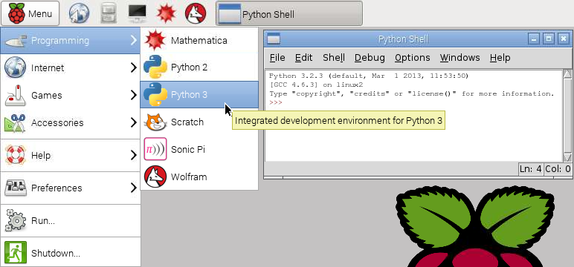

2 The windows that opens is the python shell. The shell is similar to the CLI terminal. You can type instructions at the prompt and when you press enter they will execute immediately. Try typing 5+3 and then press the enter key.

|  |
| --- |
| >>> 5+3  8 |

3 That’s good, but what if you want to write a full program? Unlike the CLI terminal, the python shell has a menu bar at the top of the window. Click File > New Window *(File on the menu bar, then Window from the drop down menu)*.

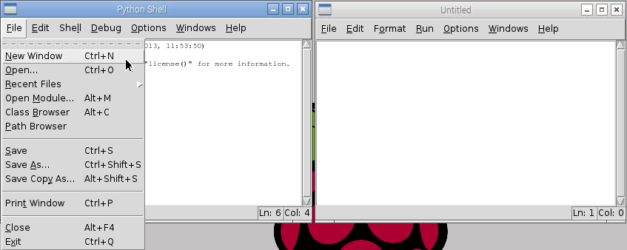

4 You can write python program in this window, save it and then run it when you like. You can begin with a quick “hello world” type program. Type the following in the new window:

|  |
| --- |
| print(“Hello world!”) |

5 To run the program select the Run menu, then the Run Module menu item. The program will run and display its output in the python shell window.

|  |
| --- |
| >>>  Hello world! |